1. Basically you need to add translate, scale and rotation methods in gameobject class rather than doing transformations here directly here…also I have little bit off code in gameobject and shader classes to help you

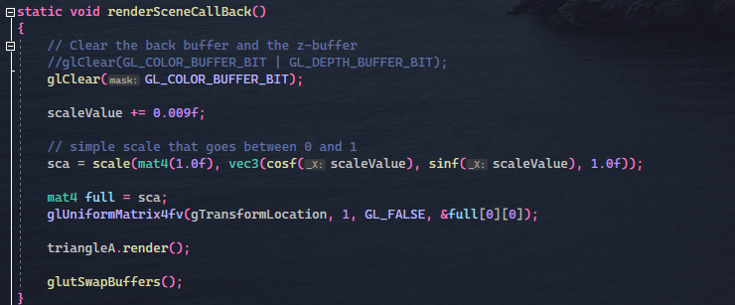

Code to help

You need to call the updateShader method in renderSceneCallback before rendering each objects

1. Once you have the transformations working and everything is working properly then I can help you with the Camera stuff
2. Note: There’s no LIGHTING atm in the scene so you also need to add that